**PICTURES:**

1. **Output with the simple corrupted text 'thesamsung?beeped', demonstrating the program working with punctuation.**

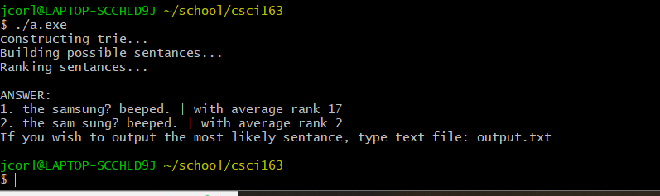

**Dictionary, output file, corrupted file below:**

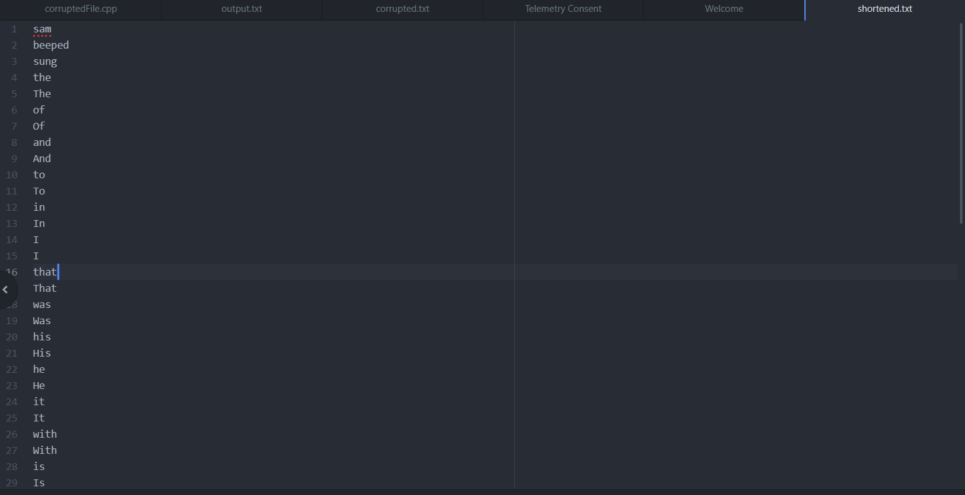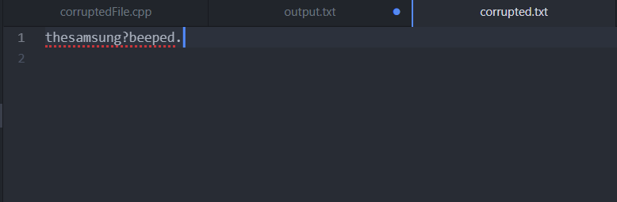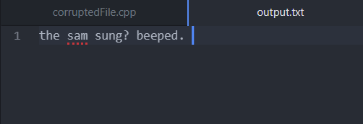

* This is the most likely sentence due to 'samsung' being the last item in the dictionary. Rank is determined by means of word likelihood alone, rather than grammar.